FGCC Softball 2024 - info sheet
Fort Garry Community Centre Softball program is back for another season. This program is open to players ages 5 to 19 residing within our extended catchment area, as shown on the below map:
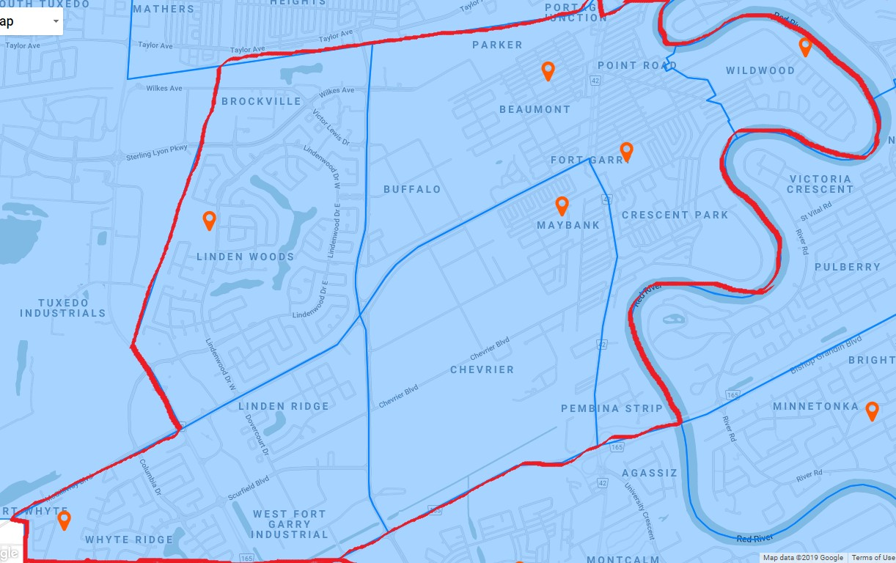

Registration is available until April 1, 2024 on our website: www.fortgarrycc.ca OR http://fortgarrysoftball.rampregistrations.com/

The FGCC Baseball program generally runs in May and June, with start dates dependent on weather and field conditions. Participants will have two games per week with most teams holding additional practices during the week.

League/Division playoffs typically are held in late June. For those teams that qualify, provincial playoffs commence in early July.

Prior to registering, please refer to the below chart for age division, fee and schedule information:
*Note: Ages are as of December 31st in the same year in which the season is played.

Age | Level | Game Days  (Subject to Change) | Fees
5 – 7 (Born 2017, 2018, 2019) | Learn to Play | Saturday or Sunday mornings | $75.00
8 – 9 (Born 2015, 2016) | U9 | Tuesday/Thursday | $125.00
10 – 11 (Born 2013, 2014) | U11 | Monday/Wednesday | $200.00
12 – 13 (Born 2011, 2012) | U13 | Tuesday/Thursday | $200.00
14 – 15 (Born 2009, 2010) | U15 | Monday/Wednesday | $200.00
16 – 17 (Born 2007, 2008) | U17 | Tuesday/Thursday | $200.00
18 – 19 (Born 2005, 2006) | U19 | Monday/Wednesday | $200.00

Volunteers

Fort Garry Softball requires parents to step up to volunteer within their child’s program. Positions include head coach, assistant coach, team manager, score keeper and general volunteers. Many important tasks require NO softball knowledge. To learn more about how you can lend a hand, please contact the FGCC softball convenor, Katherine Anderson, by email at katandshane09@hotmail.com

Coaches and volunteers are required to register through RAMP as well so they can be placed on the team’s roster.

Equipment and Uniform Requirements

Once teams are formed, managers will meet with parents to provide jerseys (to be returned at the end of the season) as well as hats and other equipment. This year we will require a “jersey deposit” at the beginning of the season to assure all uniforms are returned. An additional fee for non-returnable merchandise may be collected, along with tournament fees. This may differ from team to team.

Players of all age groups are expected to purchase their own helmet, infield mask and glove. Baseball pants are recommended, as well as cleats or running shoes. Bats can also be supplied by the club, but most players have their own.

Tryouts and Team Formation

Tryouts for AAA softball take place in the fall after the season has finished. Fort Garry is part of the Smitty’s Terminators organization. More info can be found at https://www.smittysterminators.ca/ or contact our softball convenor Katherine at katandshane09@hotmail.com

For those players who do not make the AAA team, they will be placed on an A team in their correct catchment. Depending on the number of players and coaches, some age groups may be asked to play for another association, ie South Winnipeg, Varsity View…

Registration

Online registration takes place until April 1, 2024. Late registrations will be charged an additional $50 late fee and will only be accepted if teams have space.
To register, go to our website (fortgarrycc.ca) and click the Softball link which will take you to the RAMP portal. Or you can go directly to the RAMP website http://fortgarrysoftball.rampregistrations.com/ New players will create a family account following the prompts; returning players to the RAMP system will use the family account already established. Coaches and volunteers are required to register through RAMP as well so they can be placed on the teams roster.
Payment is accepted online by credit card (Visa or Mastercard) or by eTransfer to fgcc@fortgarrycc.ca. For eTransfers, please set the password as ‘winnipeg’ (no quotation marks). If neither of these payment methods work for your family, please contact the office by email or phone (204-505-3970) to make alternate arrangements.
Cancelled registrations will be refunded in full, less a $20 administration fee. No refunds to be issued after April 15th as league payments have been made.
Financial subsidies to reduce program costs are available to qualifying families, and can be completed in person at the Hobson office, 880 Oakenwald. Please contact the office by email or phone prior to arriving to ensure staff will be present to assist. Subsidy information and sample applications are available on the GCWCC website at https://www.gcwcc.mb.ca/grants-and-subsidies/ . The Jumpstart Grant link is found at: http://jumpstart.canadiantire.ca/en.html
Please do not contact the FGCC office to confirm your registration. You can expect coach contact prior to the start of the season, which will provide additional information on rosters, practice and game schedules, volunteers, etc. If you haven’t heard from a coach or team manager by the last week of April, please contact the FGCC softball convenor, Katherine Anderson at katandshane09@hotmail.com
For registration, subsidy or payment inquiries, please email info@fortgarrycc.ca

We look forward to seeing you and your child on our fields this spring to play ball!

